Install the NuGet Package in the Project

An alternative to manually downloading and copying the chromedriver.exe file is to install the NuGet Package in the project.

The first step to do this is navigate to this URL <https://github.com/jsakamoto/nupkg-selenium-webdriver-chromedriver/>

and download the package from the Visual Studio console, like shown on the page (make sure it is the correct version of ChromeDriver):

PM> Install-Package Selenium.WebDriver.ChromeDriver -Version 83.0.4103.3900

Or add it from the Tools menu > NuGet Package Manager > Manage NuGet Packages for Solution…

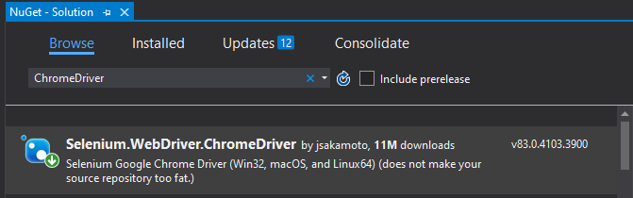

The second step is to open the project properties by right clicking on the project, or from the Project menu > Properties, and adding the _PUBLISH_CHROMEDRIVER compilation symbol in the Build properties, which will include the "chromedriver(.exe)" file into the published files.